A CASE-STUDY BASED REPORT
ON
Environmental Sensor Data Visualization Using PCA & UMAP
submitted in partial fulfilment of the requirements for the Course
MACHINE LEARNING
BACHELOR OF TECHNOLOGY
in
A.Y.: 2026-27
by
Name: K.Bhargavi roll no:2520030074
Name: M.Apoorva roll no:2520030078
Under the Esteemed guidance of
Mr. Shaik Asif
Asst.Professor, Dept. of CSE




INDEX
Abstract
Introduction
Background
Motivation for the Project
Overview of the Work Carried Out
Scope and Responsible-Use Statement
Problem Statement
Case-Study Scenario
Central Case-Study Question
Formal Problem Definition
Objectives that Guide the Study
Assumptions and Limitations
Dataset and Exploratory Data Analysis
About the Dataset
Purpose of EDA
Preparation Steps Actually Performed
EDA Exploration - Implementation
Summary of EDA Findings
Algorithm Selection and Implementation

Conclusion

1.Abstract
Environmental sensor data contains multiple measurements related to air quality and meteorological conditions. Since many features are recorded simultaneously, it can be difficult to analyze relationships and visualize the data effectively. This case study focuses on reducing the dimensionality of environmental sensor data and identifying groups of similar observations.
The Air Quality UCI dataset is used in the study, with 13 numerical environmental features selected for analysis. The data is first cleaned by removing unnecessary empty columns, replacing the value -200 with missing values, and filling missing values using the median. The selected features are then standardized.
Principal Component Analysis (PCA) and Uniform Manifold Approximation and Projection (UMAP) are used to reduce the 13-dimensional data into two dimensions for visualization and comparison. K-Means clustering is then applied to the UMAP representation to form four clusters. Finally, the original environmental features are analyzed cluster-wise by calculating average values and comparing them with the overall averages. This helps describe the characteristics of the different groups of environmental observations.

2. Introduction

2.1 Background
Machine learning provides techniques to analyze data and identify useful patterns. Environmental monitoring generates large amounts of air-quality and meteorological sensor data with multiple features. In this project, 13 numerical environmental features such as CO, NOx, NO₂, temperature, relative humidity, and absolute humidity are analyzed. PCA and UMAP are used to reduce the data into two dimensions for easier visualization, followed by K-Means clustering to identify similar observations.
2.2 Motivation for the Project
The motivation for this project is to make high-dimensional environmental sensor data easier to understand and visualize. PCA and UMAP help reduce the number of dimensions, making it easier to observe patterns and relationships. K-Means clustering is used to identify groups of similar environmental observations.
2.3 Overview of the Work Carried Out
The project follows these main steps:
Dataset → Preprocessing → Feature Selection → Standardization → PCA + UMAP → Visualization → K-Means Clustering → Cluster Analysis
The Air Quality UCI dataset is cleaned by handling unnecessary columns and missing values. The selected 13 features are standardized before applying PCA and UMAP. The resulting visualizations are compared, and K-Means clustering is applied to the UMAP representation to form four groups. The original features are then analyzed to describe each cluster.
2.4 Scope and Responsible-Use Statement
The project focuses on using PCA, UMAP, and K-Means to analyze and visualize environmental sensor data. It demonstrates the process of preprocessing, dimensionality reduction, visualization, and clustering for academic purposes. The identified clusters represent patterns in the dataset and should not be considered as direct environmental conclusions.

3. Problem Statement

3.1 Case-Study Scenario
Consider an environmental monitoring system that collects air-quality and meteorological measurements from different sensors. Since multiple environmental features are recorded together, it becomes difficult to visualize the data and identify groups of similar observations. The available sensor data can therefore be processed using dimensionality-reduction techniques and clustering to understand the patterns present in the dataset.
3.2 Central Case-Study Question
How can environmental sensor data be reduced and visualized using PCA and UMAP, and how can K-Means clustering be used to identify groups of similar environmental observations?
3.3 Formal Problem Definition
The problem is formulated as a dimensionality-reduction and clustering problem. The input consists of 13 numerical environmental features from the Air Quality UCI dataset. The objective is to preprocess and standardize the data, reduce its dimensions using PCA and UMAP, and apply K-Means clustering on the UMAP representation to form four groups of similar observations.
3.4 Objectives that Guide the Study
- To understand and analyze the environmental sensor features in the dataset.
- To perform appropriate data preprocessing and handle missing values.
- To reduce the dimensionality of the data using PCA and UMAP.
- To apply K-Means clustering to identify groups of similar observations.
- To analyze and describe the characteristics of the identified clusters.
3.5 Assumptions and Limitations
Assumptions:
- The environmental sensor data is available in the required format.
- The selected 13 numerical features are suitable for the analysis.
- The preprocessing and standardization steps provide suitable data for PCA, UMAP, and clustering.

Limitations:
- The study is based on the available Air Quality UCI dataset.
- UMAP dimensions are not directly related to the original environmental features.
- The identified clusters represent patterns in the dataset and may not directly explain real-world environmental causes.
4. Dataset and Exploratory Data Analysis

4.1 About the Dataset
The project uses the Air Quality UCI Dataset for environmental sensor data analysis and visualization.
The dataset contains air-quality and meteorological sensor measurements that are used to understand patterns and groups of similar environmental observations.
Input Features:
- CO (Carbon Monoxide)
- NOx (Nitrogen Oxides)
- NO₂ (Nitrogen Dioxide)
- C6H6 (Benzene)
- Temperature
- Relative Humidity
- Absolute Humidity
- Other numerical environmental sensor measurements
Selected Features:
- 13 numerical environmental features are selected for the analysis.
The features are preprocessed by handling missing values and invalid -200 values. The selected features are then standardized before applying PCA, UMAP, and K-Means clustering.
efore, preprocessing and encoding are performed before applying the machine learning algorithm.

4.2 Purpose of EDA
The purpose of Exploratory Data Analysis (EDA) is to understand the environmental sensor dataset before applying dimensionality reduction and clustering techniques.
EDA is performed to:
- Understand the structure and characteristics of the dataset.
- Examine the available environmental sensor features.
- Identify missing and invalid values in the dataset.
- Analyze the distribution of the environmental measurements.
- Understand the relationships between different sensor features.
- Prepare the data appropriately for PCA, UMAP, and K-Means clustering.

4.3 Preparation Steps Actually Performed
The dataset was first loaded and examined to understand its structure and available features. Unnecessary empty columns were removed, and the value -200 was treated as a missing value. Missing values were filled using the median, and 13 numerical environmental features were selected for further analysis. The selected features were then standardized so that they could be used effectively for PCA and UMAP. The prepared data was subsequently used for visualization, comparison, and K-Means clustering.

4.4 EDA Exploration – Implementation
Exploratory Data Analysis was performed to understand the structure, distribution, and characteristics of the environmental sensor dataset. Different statistical checks and visualizations were used to examine the environmental features, identify missing values, and understand the relationships between the sensor measurements before applying PCA, UMAP, and K-Means clustering.
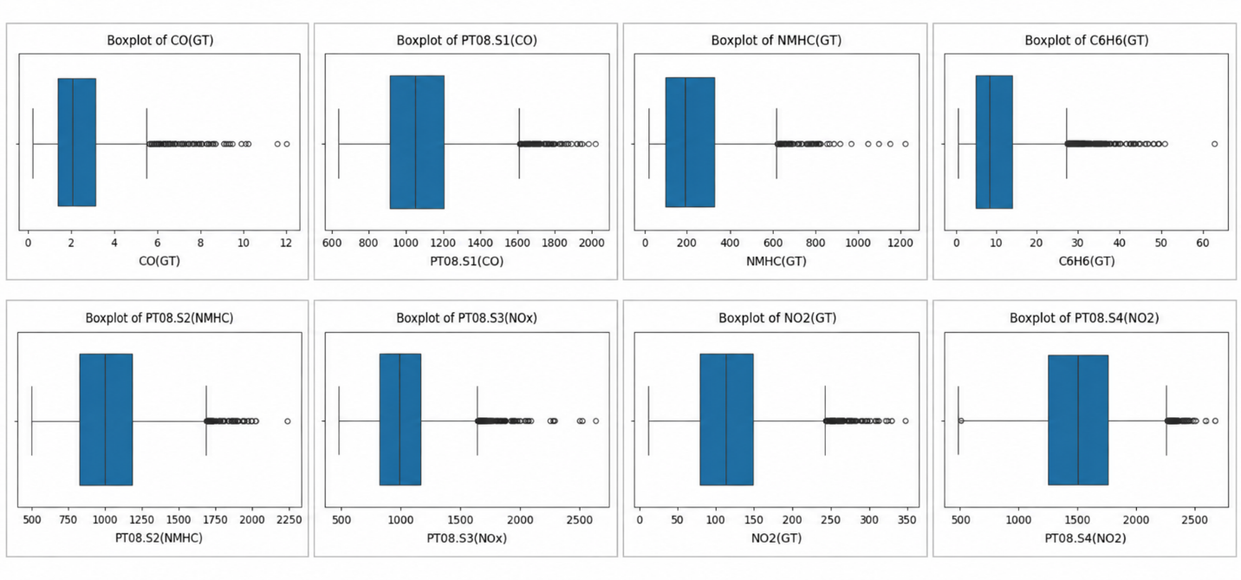

4.5 Summary of EDA Findings

The exploratory data analysis provided an overall understanding of the environmental sensor features in the dataset. The analysis showed variations in pollutant and meteorological measurements such as CO, NOx, NO₂, temperature, and humidity. Missing and invalid values were identified and handled during preprocessing. These observations helped in understanding the dataset and preparing the selected features for dimensionality reduction and clustering.

5.Algorithm Selection and Implementation
PCA and UMAP were selected for this project because the environmental dataset contains multiple numerical features that are difficult to visualize directly. The selected features were standardized and reduced to two dimensions using PCA and UMAP. The resulting representations were visualized and compared. K-Means clustering was then applied to the UMAP representation to identify groups of similar environmental observations.

5.1 Algorithm Used – Multinomial Logistic Regression
PCA and UMAP were selected as dimensionality-reduction techniques to represent the 13 environmental features in two dimensions. PCA creates new components that represent important variations in the data, while UMAP provides a lower-dimensional representation of the observations. K-Means clustering was then applied to the UMAP representation to form four groups of similar observations. The original environmental features were analyzed to understand the characteristics of each cluster.
5.2 Model Training and Prediction
The preprocessed and standardized data was given as input to PCA and UMAP. Both techniques reduced the 13-dimensional environmental data into two dimensions for visualization. The PCA and UMAP representations were then compared to observe the distribution of the observations. K-Means clustering was applied to the UMAP representation, producing four clusters. The original feature values were then analyzed for each cluster.
5.3 Model Evaluation
The PCA and UMAP visualizations were used to understand how the environmental observations are distributed in two-dimensional space. The visualizations allow similar observations to be compared based on their positions in the reduced representation. After clustering, the average values of the original environmental features were calculated for each cluster and compared with the overall averages. This helped describe the characteristics of the different groups.

5.4 Confusion Matrix
K-Means clustering was used to divide the UMAP representation into four groups. Each cluster represents observations with similar characteristics in the reduced feature space. The original environmental features were examined for each cluster to identify relatively higher and lower values. Comparing the cluster averages with the overall averages helped provide a better interpretation of the groups, since UMAP dimensions are not directly connected to the original environmental variables.

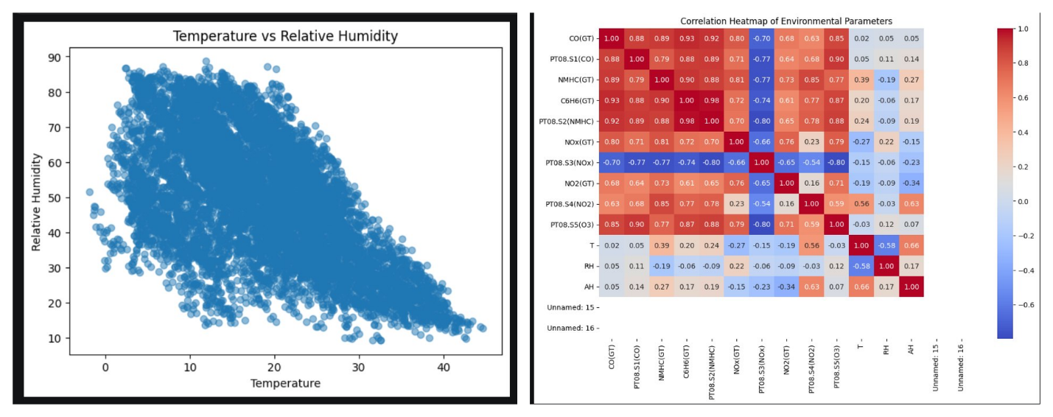

- Conclusion
The project successfully demonstrated the use of machine learning techniques for visualizing and analyzing environmental sensor data. Exploratory Data Analysis helped in understanding the structure and characteristics of the dataset, while preprocessing prepared the data for further analysis. PCA and UMAP were used to reduce the 13 environmental features into two dimensions and compare their visual representations. K-Means clustering was then applied to the UMAP representation to form four groups, followed by analysis of the original environmental features to understand the characteristics of each cluster. Overall, the project demonstrates how dimensionality reduction and clustering can be used to identify and visualize patterns in environmental sensor data.

Signature of the Team members

